Post-Worship Coffee, Conversation and Connection
We are looking for 10 people to join our post-Worship group following our morning service. Grab a cup of coffee & goodie and take 30 minutes to share and reflect deeper during this Lenten Season.

Coins for Lent
During the month of March would you consider using this time before Easter to contribute loose coins to help supply funds for food assistance, rent relief, and other needs as they arise through the Pastor’s Discretionary Fund.
Designate a container for your contributions and use the "Coins for Lent Giving Calendar" as your guide. Items on the daily guide will remind us of all we have and how little others may have. Each Sunday, pray as a family for the project and the people who will benefit from your gifts.

Special Love Offering for Christina Fitch. Due to her accident the Administrative Board wants to support and help Christina and her family through a special offering to be received on Sunday April 11th. Please keep holding them in your prayers.

Next Sunday, join us at 9:00 am for fellowship and breakfast goodies prior to our first Easter gathering in over a year. We will observe safety protocols and maintain safety. Consider inviting a church member you haven’t seen in a long while to join you.

W

Valley Forge United
Methodist Church

March 28, 2021
Valley Forge United Methodist Church
March 28, 2021

Welcome to our Worship Service today. Our Service reflects our commitment to Word and Sacrament. You will hear Scriptures read and expounded, sing hymns and praise songs, spend time in silence and prayer as part of our weekly gatherings. We are honored you have joined us today, come often and whenever you have opportunity!

GATHERING
We gather as a community and prepare our hearts to Worship God.
Introduction to the day Pastor Brent L. Nidiffer

Proclamation of the Entrance to Jerusalem
Hear from the Gospel of Mark 11:1-11 how our Lord Jesus entered Jerusalem.

Opening Prayer: Pastor Brent L. Nidiffer
Almighty God,
on this day your Son Jesus Christ entered the holy city of Jerusalem
and was proclaimed King
by those who spread their garments and palm branches along his way.
Let those branches be for us signs of his victory,
and grant that we who bear them in his name
may ever hail him as our Lord,
and follow him in the way that leads to eternal life.
In his name we pray. Amen.
Processional Hymn: “All Glory Laud and Honor” No.280
LISTENING
We listen for the Word of God through song, scripture and preaching

7:00 pm
Join us for this service as Scripture, music, ancient prayer and reflection provide a powerful setting for the drama of the crucifixion and death of our Lord Jesus.

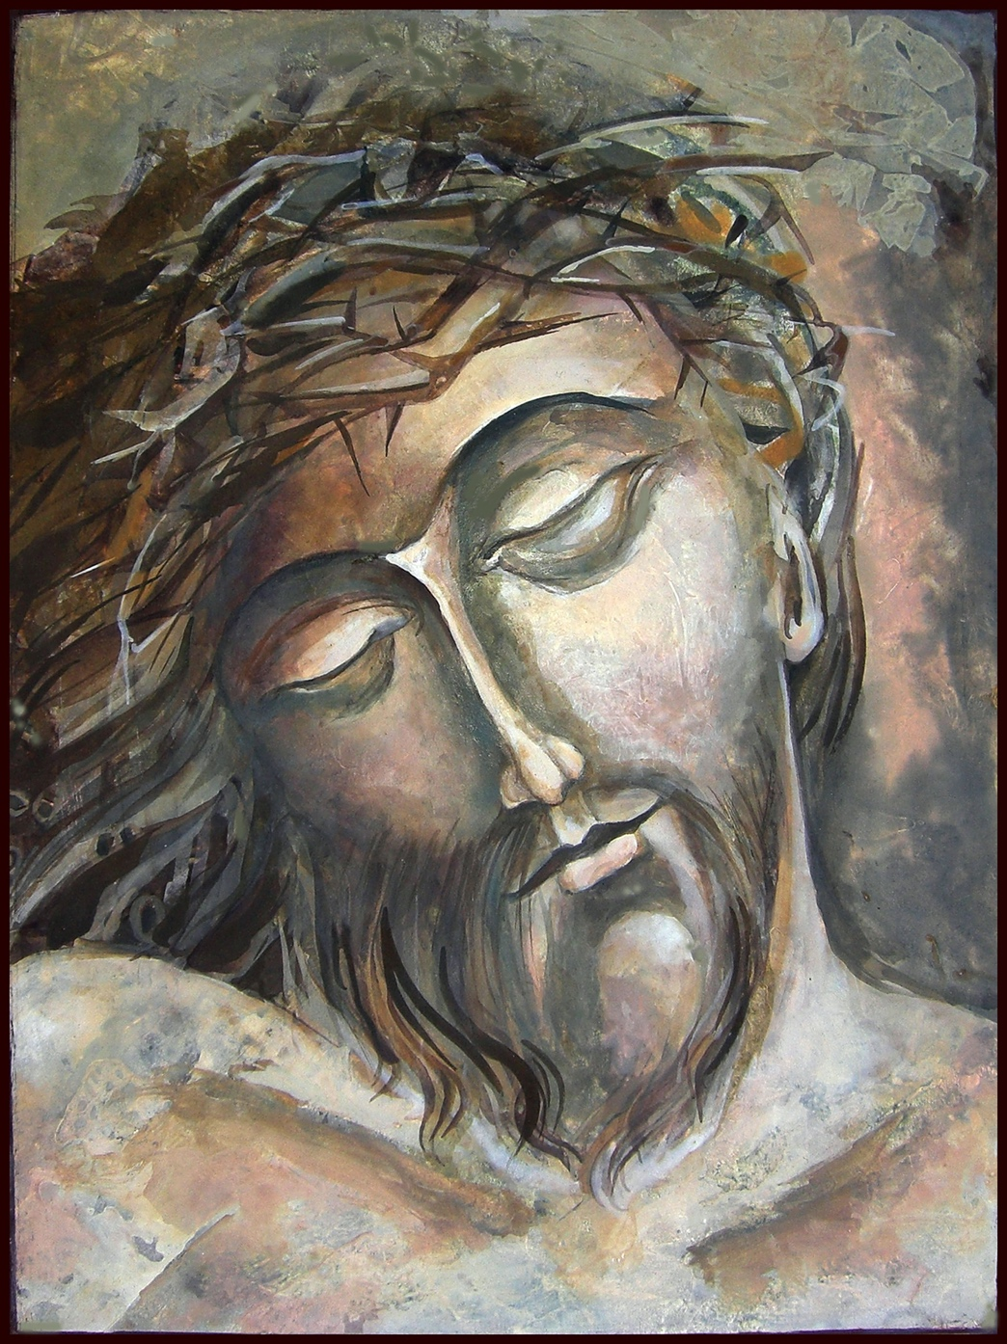

Responsorial Psalm 31 Psalter No. 764
1 ºIn you, O Lord, do I ^{p}take refuge;
^{q}let me never be put to shame;
in your ^{r}righteousness deliver me!
2 Incline your ear to me;
rescue me speedily!
Be ^{s}a rock of ^{t}refuge for me,
a strong fortress to save me!
3 For you are my rock and my fortress;
and for your ^{u}name’s sake you lead me and guide me;
4 ^{v}take me out of ^{w}the net they have hidden for me,
for you are my ^{x}refuge.
5 ^{y}Into your hand I commit my spirit;
you have redeemed me, O Lord, ^{z}faithful God.
6 I ªhate¹ those who pay ^{b}regard to worthless ^{c}idols,
but I trust in the Lord.
7 I will rejoice and be glad in your steadfast love,
because you have seen my affliction;
you have ^{d}known the distress of my soul,
8 you have not ^{e}delivered me into the hand of the enemy;
you have set my feet in ^{f}a broad place.
9 Be gracious to me, O Lord, for I am ^{g}in distress;
^{h}my eye is wasted from grief;
my soul and my body also.
10 For my life is spent with sorrow,
and my years with sighing;
my strength fails because of my iniquity,
and ^{i}my bones waste away.
11 Because of all my adversaries I have become ^{j}a reproach,
especially to my ^{k}neighbors,
and an object of dread to my acquaintances;
those who see me in the street ^{l}flee from me.
12 I have been ^{m}forgotten like one who is dead;
I have become like ^{n}a broken vessel.
13 For I ºhear the whispering of many—
terror on every side!—^{p}as they scheme together against me,
as they plot to take my life.
14 But I ^{q}trust in you, O Lord;
I say, “You are my God.”
15 My ^{r}times are in your hand;
^{s}rescue me from the hand of my enemies and from my persecutors!
16 ^{t}Make your face shine on your servant;
save me in your steadfast love

Hymn: “Precious Lord, Take My Hand” No. 474

Scripture Reading: Philippians 2:5-11
Reader: The Word of the Lord.
People: Thanks Be To God.

Homily Pastor Brent L. Nidiffer

Hymn “He is Lord” No. 177

Proclamation of the Passion Story
Mark 14:1-15:47 Reader’s Theatre

RESPONDING
We respond to the hearing of God’s Word through confession, affirmation of faith, prayers, offering and monthly communion

Hymn: “O Sacred Head now Wounded” No. 286

Confession And Pardon:
God of all times and places, we confess that we would rather join the crowds than stand alone. We prefer the popular point of view to a solitary witness for justice and truth. We like safety and security while shrinking from the risk of involvement. We'll sing "hosanna" when everyone else is doing so—but not when the hostile "Good Friday" forces may hear us. We do not like to admit our lukewarm response to you, but neither do we want to be considered fanatics.
We believe Jesus Christ came into the world to save sinners. We know that means us, not just other folk involved in obvious evils everyone knows about. We ask you to be patient with us, to help us understand our own guilt. Then pour out your forgiveness in such a way that we are forever transformed. In the name of Jesus Christ.
(All Pray in Silence)

Pastor- Hear the good news: Christ died for us while we were yet sinners; that proves God’s love toward us.
In the name of Jesus Christ, you are forgiven!
People- In the name of Jesus Christ, you are forgiven!
All – Glory to God. Amen.

Prayers of/for the People
Pastoral Prayer
Lord’s Prayer
SENDING
We are sent into the world to love God and our Neighbor

Benediction:
The week stretches ahead
glory-less
and pain-full

Whether we walk with all faith or none
we look towards the cross,
knowing it is both the most human
and most divine
of all journeys

travel the road with courage,
with love,
and with the uneasy peace that is the gift of faith
into this holiest of weeks. Amen.

Hymn: “Beneath the Cross of Jesus” No.297

